DO-er LIST
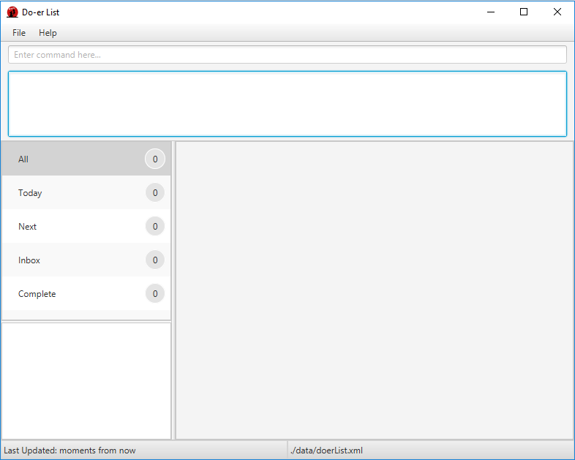
Supervisor: Si Junke Ashley
  Ng Yong Sheng |   Xiao Pu |   Chan Jing Hui Benedict |   Vu Hai Long
Table of Contents
Acknowledgements 4
About Us 5
Supervisors 5
Project Team 6
User Guide 10
About Us 11
Overview 12
Getting Started 13
Features 15
FAQ 32
Command Summary 33
Developer Guide 34
Setting up 35
Design 36
Architecture 36
UI component 39
Logic component 41
Model component 42
Storage component 44
Common classes 45
Implementation 46
Logging 46
Configuration 46
Testing 47
Dev Ops 49
Build Automation 49
Continuous Integration 49
Making a Release 49
Managing Dependencies 49
Appendix A : User Stories 50
Appendix B: Use Cases 53
Appendix C: Non-Functional Requirements 65
Appendix D: Glossary 65
Appendix E: Product Survey 66
Review of TickTick: 66
Review of WunderList 66
Review of Trello 67
Review of Google Calendar 67

Acknowledgements
- Certain aspects of this application were inspired by Marco Jakob’s Java FX tutorial.
- This program utilizes Natty Time, Pretty Time, Test FX, Guava and Jackson packages.
- This program is based off Address Book Level 4's sample code under the MIT license.

About Us
We are CS2103/T team (Wednesday 09 C4) based in the School of Computing, National University of Singapore.

Supervisors
Damith C. Rajapakse    Role: Module Coordinator | Si Junke Ashley    Role: Project Advisor

Project Team

Xiao Pu
- Components in charge of: UI
- Aspects/tools in charge of: Testing, Integration, JavaFX
- Features implemented:
  - List Tasks
  - Find Tasks
  - View Tasks
  - Delete Tasks
- Code written: [functional code][test code][docs]
- Other major contributions
  - Design UI with Yong Sheng
  - Set up Gradle, Travis, Coveralls and Codacy
  - Help other writing UI parts and GUI test cases for the features they implement.
  - Update Developer Guide to match the project at the end

Yong Sheng
- Components in charge of: UI
- Aspects/tools in charge of: Guides, Balsamiq, Markdown
- Features implemented:
  - Add Recurring Tasks
  - Help Command
  - Exit Program
- Code written: [functional code][test code][docs]
- Other major contributions
  - Design UI with Xiao Pu
  - Help to design and improve the program interface and guides to be more user-friendly
  - Refactors and spot for errors in code comments

Benedict Chan
- Components in charge of: Storage
- Features implemented:
  - Mark Tasks
  - Unmark Tasks
- Code written: [functional code][test code][docs]
- Other major contributions
  - Collating the UserGuide.md and DeveloperGuide.md with Yong Sheng

Vu Hai Long
- Components in charge of: Logic
- Aspects/tools in charge of: Testing
- Features implemented:
  - Add Tasks
  - Edit Tasks
  - Help Function
  - Task Due
- Code written: [functional code][test code][docs]
- Other major contributions
  - Do the original refractoring.

User Guide

About Us 10
Overview 11
Getting Started 12
Features 14
FAQ 31
Command Summary 32

About Us
Living in the modern and fast-paced world nowadays, we are constantly overwhelmed with tasks to do. Many people face the problem of time management as the traditional methods prove to be little effective. That is what Do-er List aims to solve.
Do-er List is a task manager that is designed for students and office workers. It is a beginner-friendly desktop program that aids you in the planning and completion of your daily tasks. It does not matter if you are planning a big birthday surprise event or recurring task of handling the laundry every now and then, Do-er List is here to resolve your problems.
This user guide aims to allow any user to seamlessly use the product, as intended to. Just follow the instructions as stated and you will get the results you desire.
Eager and excited? Then let us proceed!

Overview
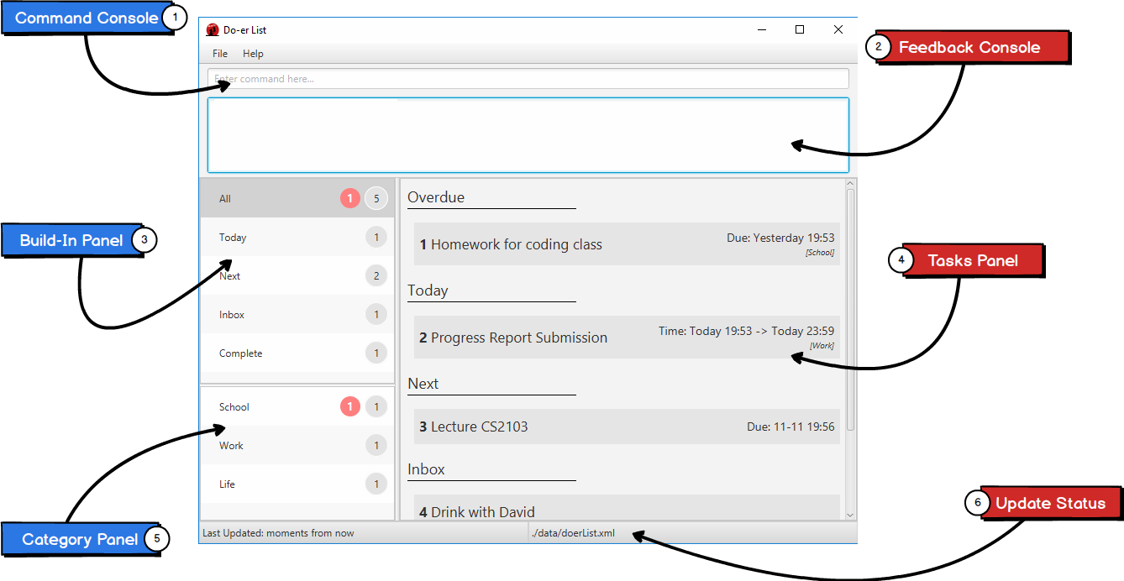
Labels | Description
1 | Type your commands in the Command Console to execute the desired commands.
2 | Feedback Console shows if your command is executed properly or not.
3 | View your build-in categories in the Build-In Panel.
4 | Tasks Panel will display all the tasks you listed in a panel.
5 | Category Panel shows all the custom categories that you have created.
6 | View your last update and file storage in Update Status.

Getting Started
Do-er List makes the process of adding, editing or deleting tasks a seamless process. Long gone are the days when you need to type in long and complicated commands or endlessly click on multiple buttons to get what you desire.
All commands have this standard format:
Command required_fields [optional_fields] ...
All commands start with a command words, followed by fields that are replaced by your inputs. The fields in the square bracket "[" and "] are optional. You can choose to not include these fields.
Please take note of the following:
- Ensure you have Java version 1.8.0_60 or later installed in your Computer.
> This app will not work with earlier versions of Java 8.
- Download the latest doerlist.jar from the releases tab.
- Copy the file to the folder you want to use as the home folder for the Do-erList.
- Double-click the file to start the app. The GUI should appear in a few seconds.
- Type the command in the command box and press Enter to execute it.
  - e.g. typing help and pressing Enter will open the User Guide in a new window.
- Some example commands you can try:
  - add/t Do post-lecture quiz /s today 10:00 /e tomorrow 12:00 /c CS2103: adds a task called Do post-lecture quiz to the Do-er List that starts today at 10:00 and ends tomorrow at 13:00 under the category CS2103.
  - list CS2103: lists all tasks in CS2103
  - delete 1: deletes the 1st task shown in the current list
  - exit: exits the application
- Refer to the Features section below for details of each command.

Features
Command Format
- Words in UPPER_CASE are the parameters.
- Items in SQUARE_BRACKETS are optional.
- Items with ... after them can have multiple instances.
- If a command has multiple parameters, the order of parameters doesn't matter.

Viewing help: help
Format: help or help [COMMAND_NAME]

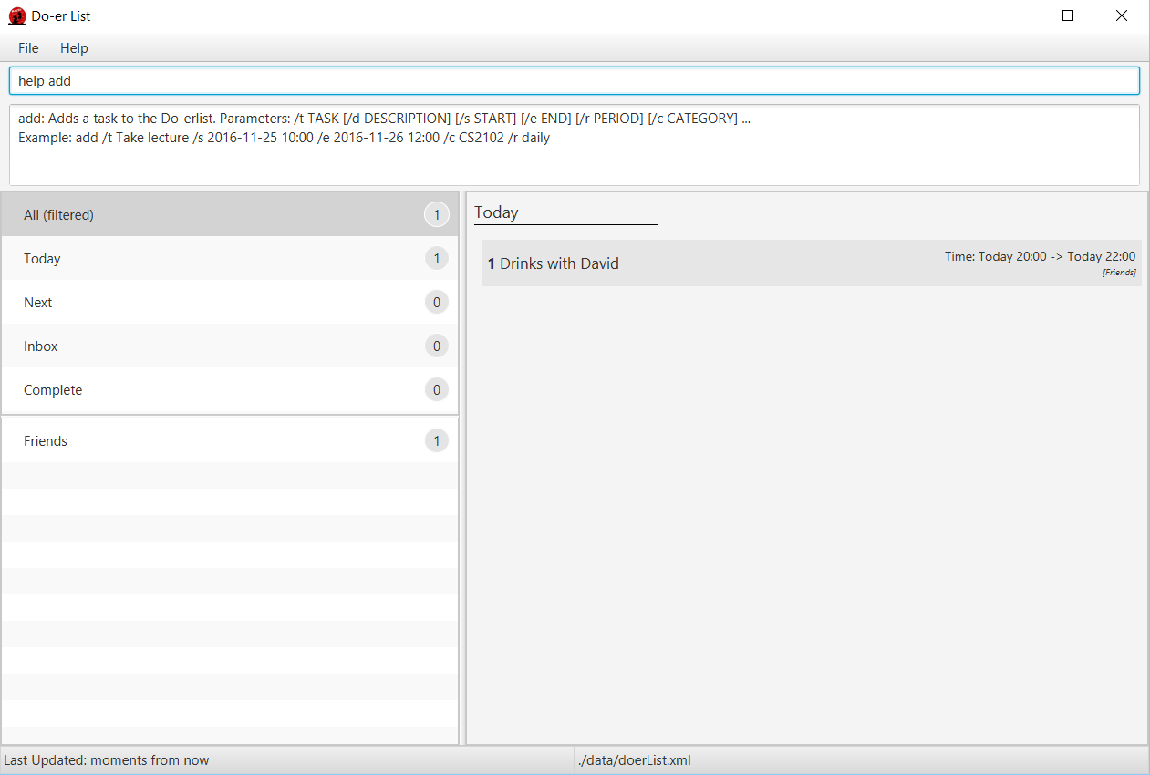
If the COMMAND_NAME is supplied, it will display the instructions of using that command.
Help is also shown if you enter an incorrect command e.g. abcd

Adding a task: add
Adds a task to the Do-erList
Format: add /t TITLE [/d DESCRIPTION] [/s START] [/e END] [/c CATEGORY]
[/r RECURRING] ...

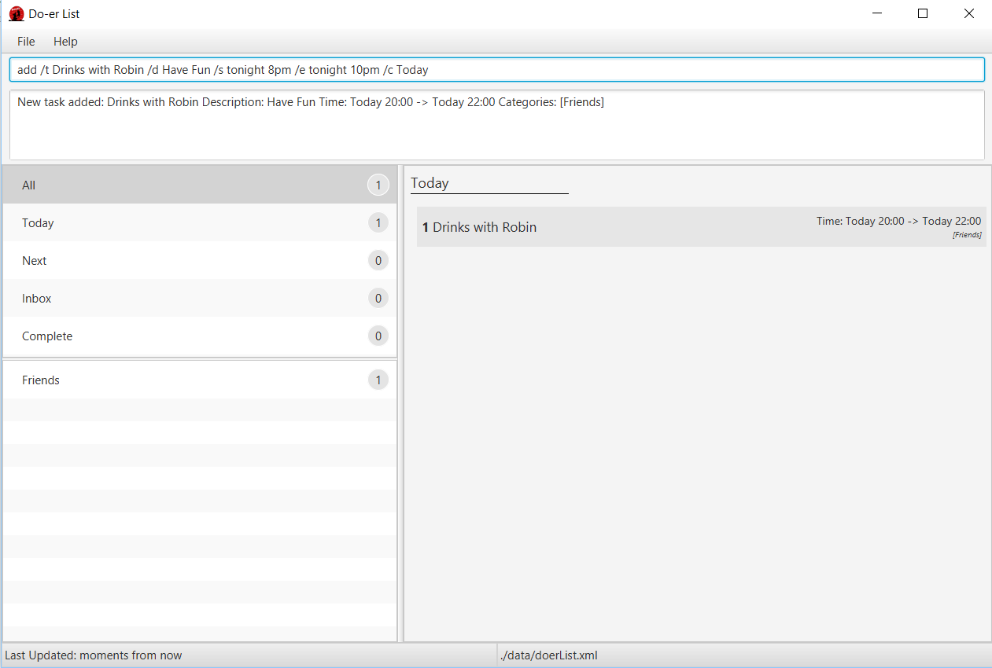
- You can choose to have no categories or any number of them in your task.
- The START or END parameter supports natural language input.
- RECURRING intervals can also be added in and supports in natural language input.
- If the START date is missing, the Doer-List set it to its current timing and date by default.
- If there is no START or END parameters, the Doer-list will create task without start date and end date and move it to Inbox default category.
- Supported list for natural language for START and END:
  - next X hours / days / weeks / months
    - X can be any number: 1, 2, 3, ...
  - today
  - tomorrow
  - next week / month
- Supported list for natural language for RECURRING tasks:
  - daily
  - weekly
  - monthly
  - yearly
Examples:
- add /t Weekly Laundry /s 2016-11-23 21:00 /c Chores
- add /t Daily Exercise and Workout!
- add /t Call Mum in Hanoi /d Limit chat timing for overseas charges /s tomorrow 8pm /e tomorrow 10pm /c Optional
- add /t Check Email /s tomorrow 8pm /e tomorrow 10pm /r daily

Editing a task: edit
Edit an existing task in the Do-er List
Format: edit INDEX [/t TITLE] [/d DESCRIPTION] [/s START] [/e END] [/c CATEGORY]
[/r RECURRING] ...

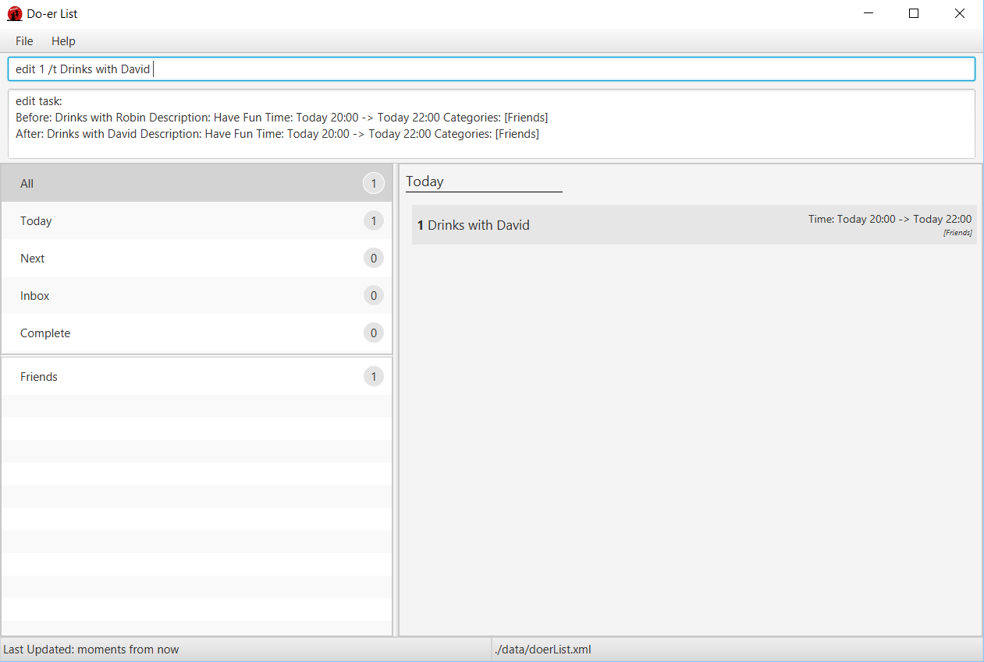

Edit an existing task by calling its index. The task's title, description, start date, end date, recurring intervals and categories can be edited.
Examples:
- edit 2 /t Do the Laundry /c Chores /r Daily
- edit 3 /c Do Homework
- edit 3 /s tomorrow 23 00
Attributes that are not supplied will not be updated

Mark task as done: mark
Marks a certain task as done in the Doer-list.
Format: mark TASK_NUMBER

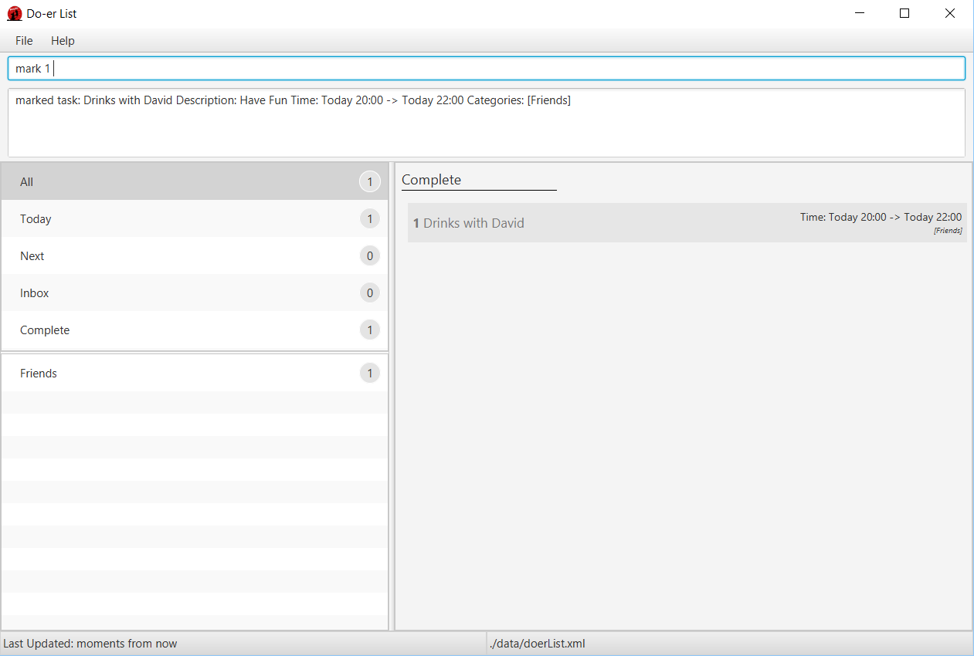
Mark task TASK_NUMBER as done. The task must exist in the Doer-list.
Examples:
- mark 5
  - Returns task number 5 as done.
  - If a recurring task is mark is done, it will automatically update its start and end date.

Unmark task as done: unmark
Marks a certain task as undone in the Doer-list.
Format: unmark TASK_NUMBER

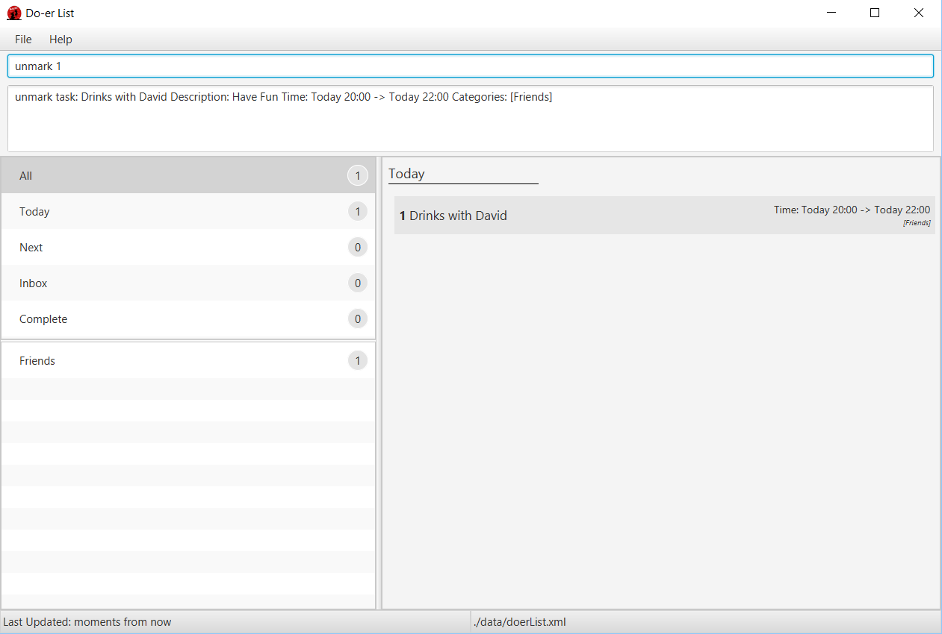
Mark task TASK_NUMBER as undone. The task must exist in the Doer-list.
Examples:
- unmark 5
  - Returns task number 5 as undone.
  - If a recurring task is mark is unmarked, it will automatically subtract its start and end date by its given recurring interval.

Listing tasks in a certain category: list
Shows a list of all tasks in the Doer-list under the specific category.
Format: list [CATEGORY]

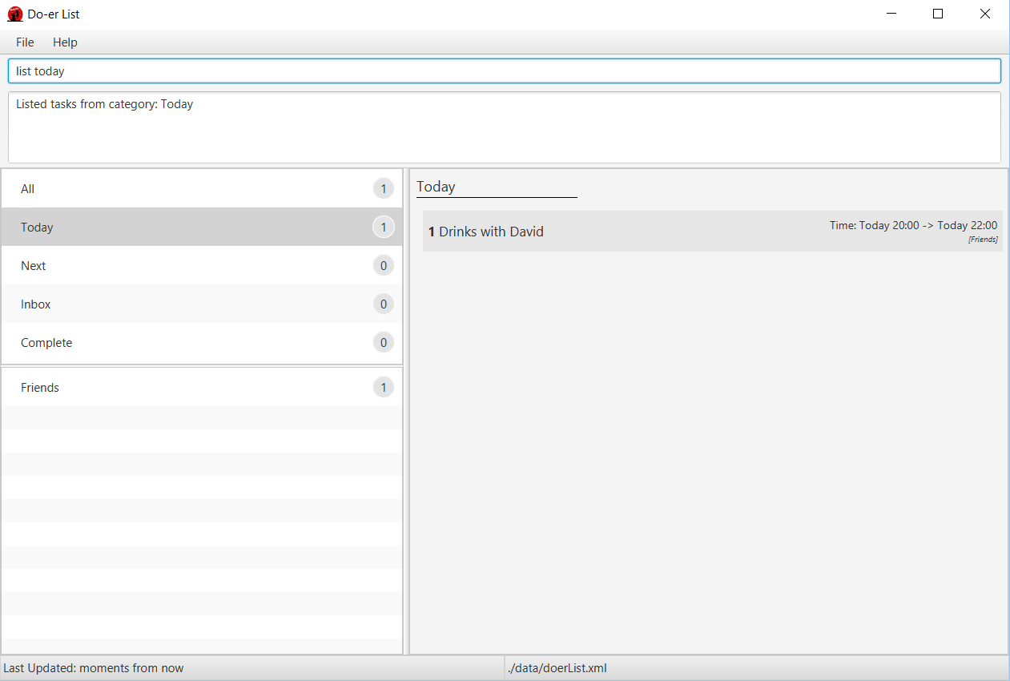
- If the CATEGORY or DATE parameter is not supplied, then it will list all tasks.
- Some build-in categories: All Today Next Inbox and Complete can be also listed.
Examples:
- list
- list Friends
- list today
- list next

Finding all tasks containing any keyword in their name: find
Finds tasks whose names contain any of the given keywords.
Format: find KEYWORD [MORE_KEYWORDS]

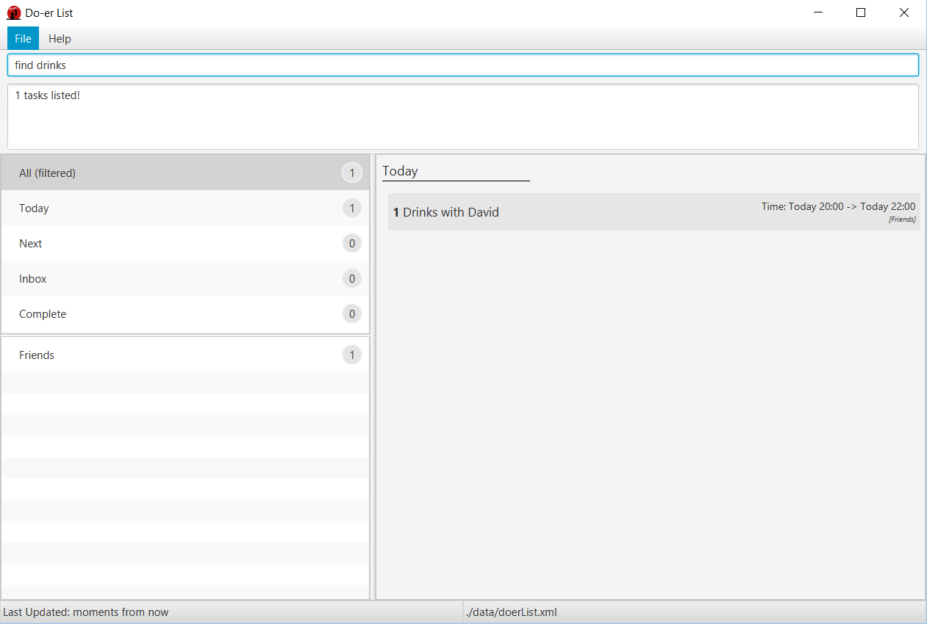
- The search is not case sensitive.
  - lecture will match LecTure
- The order of the keywords does not matter.
  - go to lecture will match Lecture go to
- Title and Description is searched.
- All data in the Do-er List matching at least one keyword will be returned
  - lecture will match have lecture
Examples:
- find david
Returns Drinks with David

View a task: view
Views the task identified by the index number used in the task panel.
Format: view INDEX

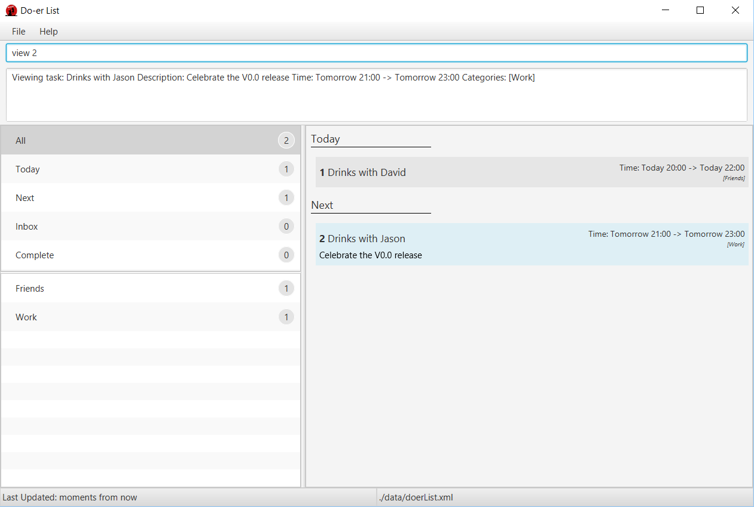
- Views the details of the task at the specified INDEX.
- The index refers to the index number shown in the most recent listing.
The index must be a positive integer 1, 2, 3, ...
Examples:
- list
view 2
Views the 2nd task in the Doer-list.
- find David
view 1
Views the 1st task in the results of the find command.

Deleting a task: delete
Deletes the specified task / event from the Do-erList.
Format: delete INDEX

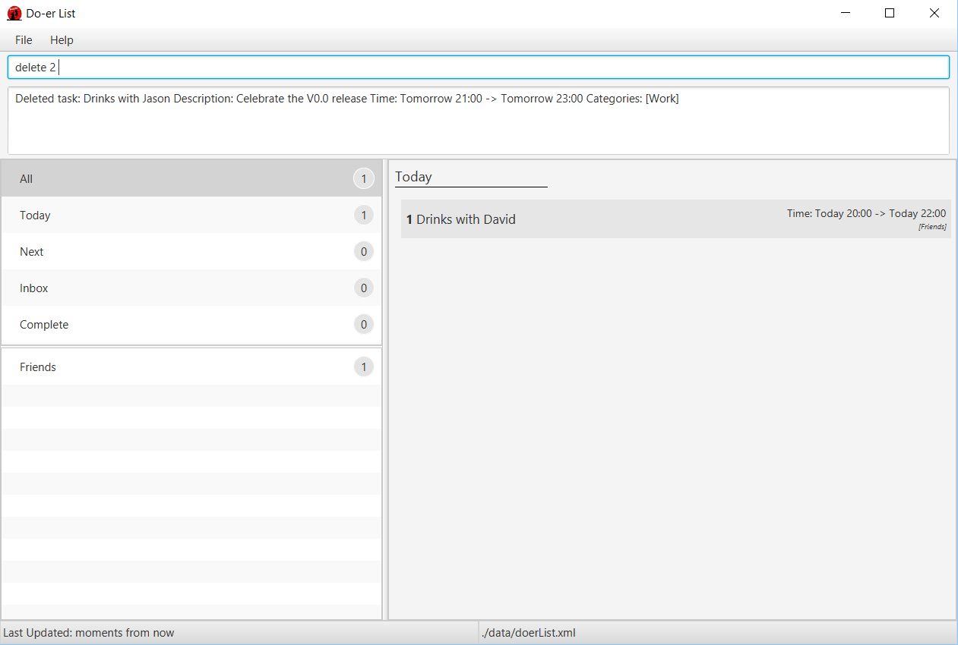
- Deletes the task / event at the specified INDEX.
- The index refers to the index number shown in the most recent listing.
The index must be a positive integer 1, 2, 3, ...
Examples:
- list
delete 2
Deletes the 2nd task / event in the Do-erList.
- find David
delete 1
Deletes the 1st task / event in the results displayed by using the find command.

Undo the most recent operation: undo
Undo the most recent operation which modify the data in the Doer-list
Format: undo

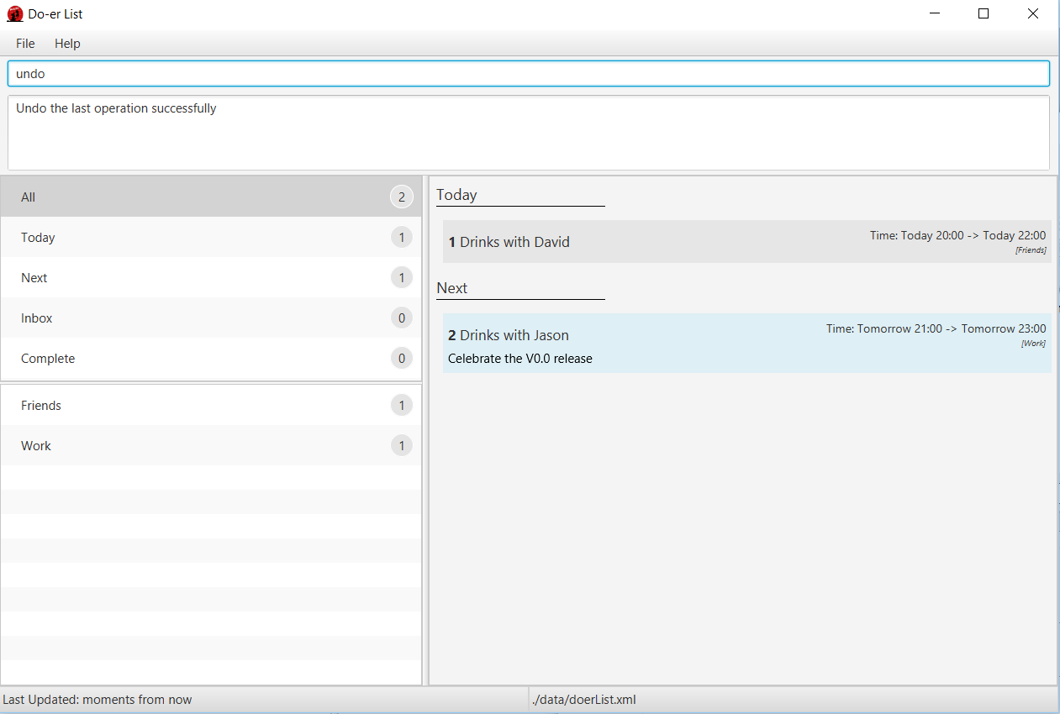

Redo the most recent operation: redo
Redo the most recent undo
Format: redo

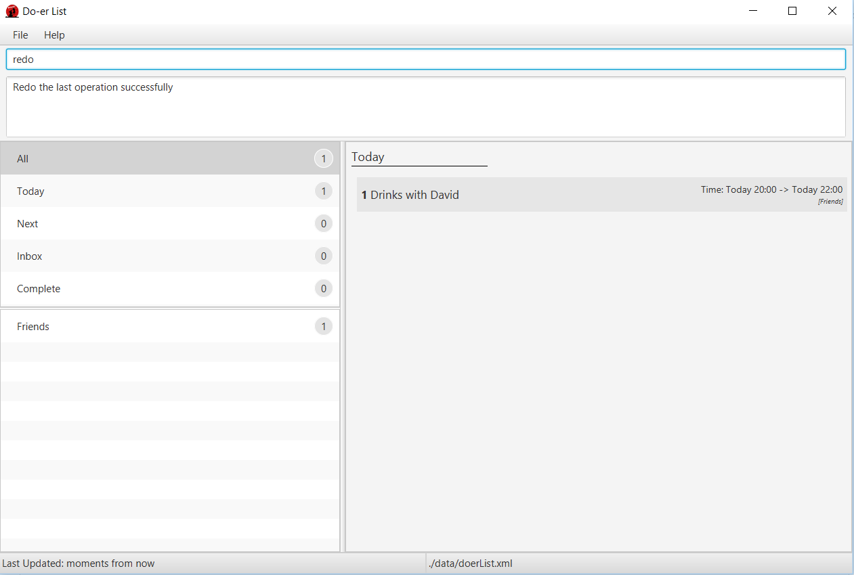
An undo command must first be used before redo command can be executed.

Find all tasks due: taskdue
Finds all tasks due on and before the date specified in the Doer-list.
Format: taskdue END_DATE

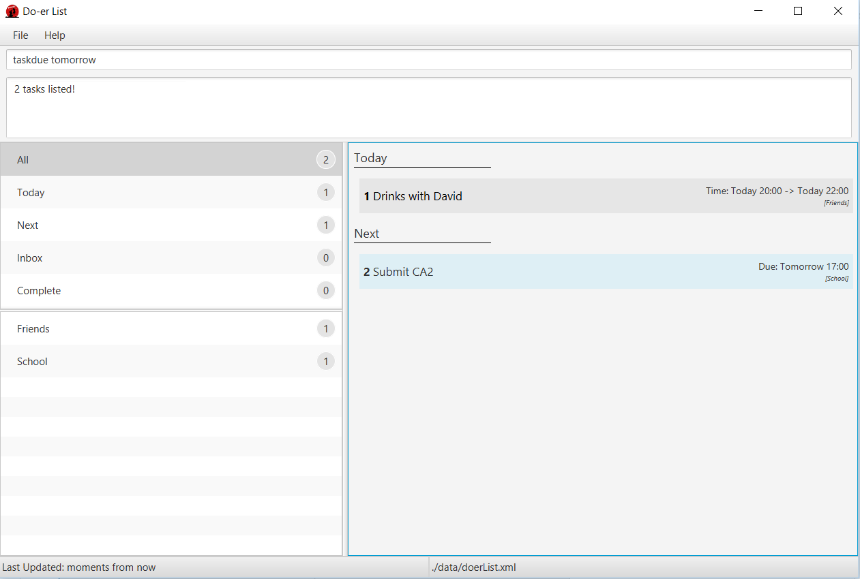
- Finds all tasks due on and before END_DATE.
- The date can be in natural language*.
- Supported list for natural language*:
  - next X hours / days / weeks / months
    - X can be any number: 1, 2, 3, ...
  - today
  - tomorrow
  - next week / month
Examples:
- taskdue tomorrow
- taskdue next 5 hours
- taskdue 2016-11-11 21:03

Changing your save location: saveto
Save the data into a new file and location
Format: saveto NEW_LOCATION

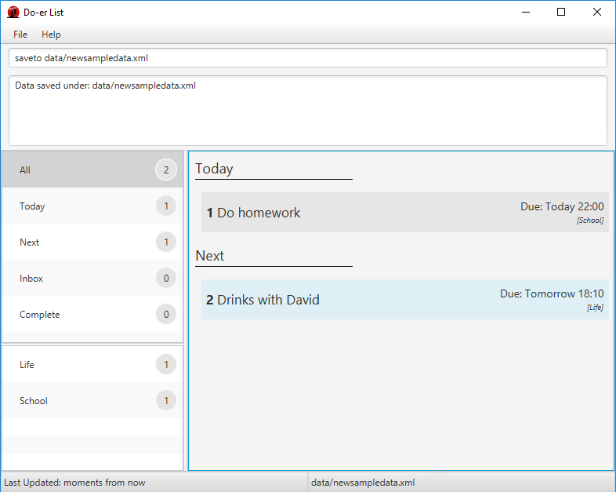
Examples:
- saveto data/newsampledata.xml

Clearing all the tasks: clear
Clearing all the tasks
Format: clear

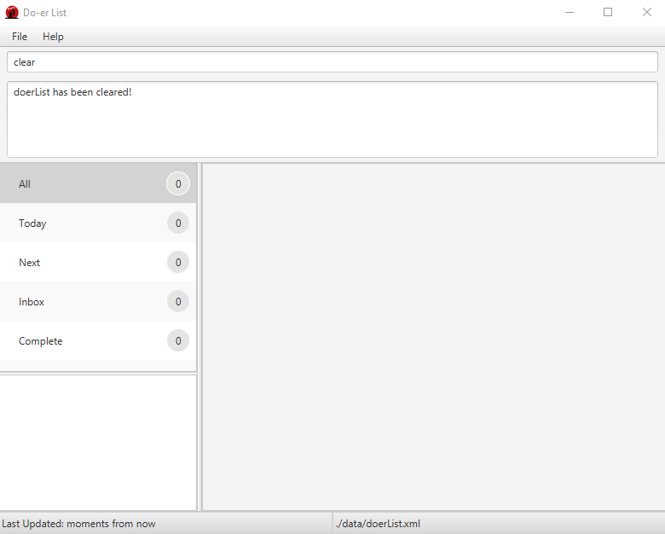

Automatic save
The Doer-list data are saved in the hard disk automatically after any command that changes the data.

Exiting the program: exit
Exits the program.
Format: exit

FAQ
Q: How do I transfer my data to another computer?
A: Install the app in the other computer and overwrite the empty data file it creates with the file that contains the data of your previous Do-er List folder.
Q: Running "doerlist.jar" gives and error or does not seem to work.
A: You will need to install the latest version of Java. Refer to the installation guide here.
Q: Where is the save button for me to save my schedule in this program?
A: Your data are saved in the hard disk automatically after any command that changes the data as aforementioned here in the guide. There is no need for you to save it manually.

Command Summary
Command | Format
Help | help [COMMAND]
Add | add /t TITLE [/d DESCRIPTION] [/s START] [/e END] [/c CATEGORY]  [/r RECURRING] ...
Edit | edit INDEX [/t TITLE] [/d DESCRIPTION] [/s START] [/e END]  [/c CATEGORY] [/r RECURRING] ...
Mark Done | mark TASK_NUMBER
Mark Undone | unmark TASK_NUMBER
List | list [CATEGORY]
Find | find KEYWORD [MORE_KEYWORDS]
View | view INDEX
Delete | delete INDEX
Undo | undo
Redo | redo
Task Due | taskdue END_DATE
Save | saveto NEW_LOCATION
Exit | exit

Developer Guide
- Setting Up
- Design
- Implementation
- Testing
- Dev Ops
- Appendix A: User Stories
- Appendix B: Use Cases
- Appendix C: Non Functional Requirements
- Appendix D: Glossary
- Appendix E : Product Survey

Setting up

Prerequisites
- JDK 1.8.0_60 or later
Having any Java 8 version is not enough.
This application will not work with earlier versions of Java 8.
- Eclipse IDE
- e(fx)clipse plugin for Eclipse (Do the steps 2 onwards given in this page)
- Buildship Gradle Integration plugin from the Eclipse Marketplace

Importing the project into Eclipse
- Fork this repository, and clone the fork to your computer.
- Open Eclipse (Note: Ensure you have installed the e(fx)clipse and buildship plugins as given in the prerequisites above).
- Click File > Import.
- Click Gradle > Gradle Project > Next > Next.
- Click Browse, then locate the project's directory.
- Click Finish.
  - If you are asked whether to 'keep' or 'overwrite' config files, choose to 'keep'.
  - Depending on your connection speed and server load, it can even take up to 30 minutes for the set up to finish. (This is because Gradle downloads library files from servers during the project set up process.)
  - If Eclipse auto-changed any settings files during the import process, you can discard those changes.

Design

Architecture
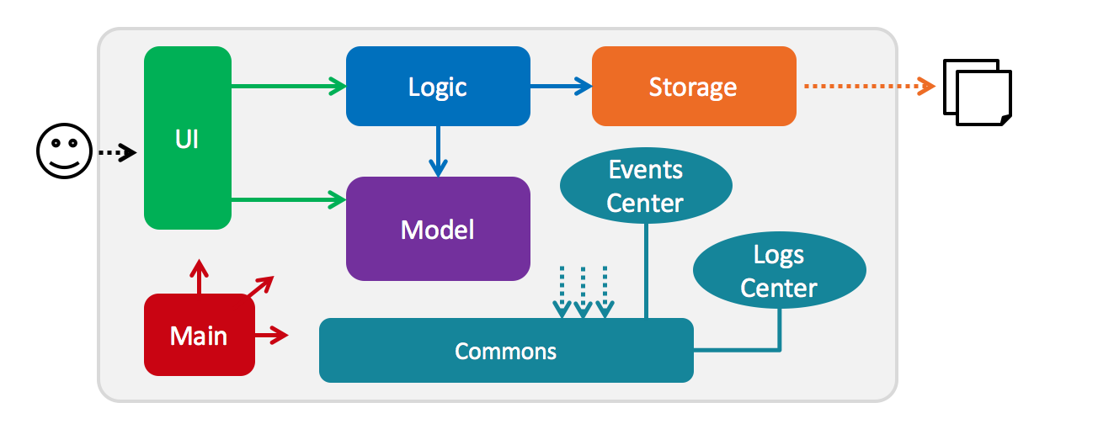
The Architecture Diagram given above explains the high-level design of the App. Given below is a quick overview of each component.
Main has only one class called MainApp. It is responsible for,
- At application launch: Initializes the components in the correct sequence, and connects them up with each other.
- At shut down: Shuts down the components and invokes cleanup method where necessary.
Commons represents a collection of classes used by multiple other components.
Two of those classes play important roles at the architecture level.
- EventsCenter : This class (written using Google's Event Bus library) is used by components to communicate with other components using events (i.e. a form of Event Driven design)
- LogsCenter : Used by many classes to write log messages to the application's log file.
The rest of the application consists four components.
- UI : The UI of the application.
- Logic : The command executor.
- Model : Holds the data of the application in-memory.
- Storage : Reads data from, and writes data to, the hard disk.
Each of the four components
- Defines its API in an interface with the same name as the Component.
- Exposes its functionality using a {Component Name}Manager class.
For example, the Logic component (see the class diagram given below) defines its API in the Logic.java interface and exposes its functionality using the LogicManager.java class.
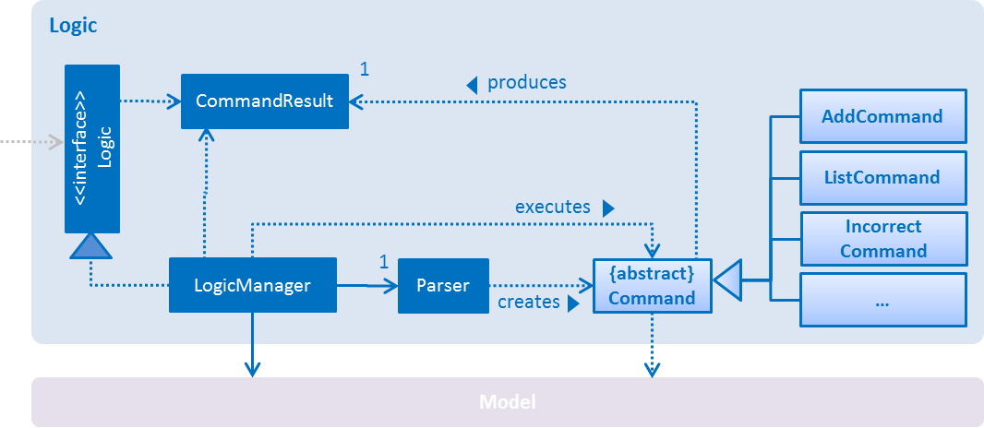

The Sequence Diagram below shows how the components interact for the scenario where the user issues the command delete 3.
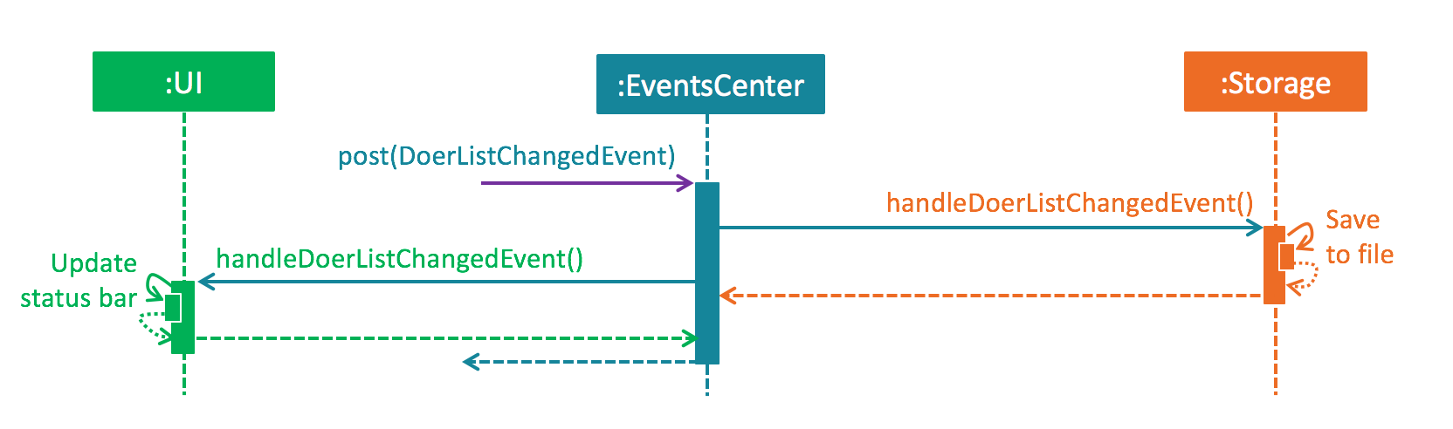
Note how the Model simply raises a DoerListChangedEvent when the Do-er List data are changed, instead of asking the Storage to save the updates to the hard disk.
The diagram below shows how the EventsCenter reacts to that event, which eventually results in the updates being saved to the hard disk and the status bar of the UI being updated to reflect the 'Last Updated' time.
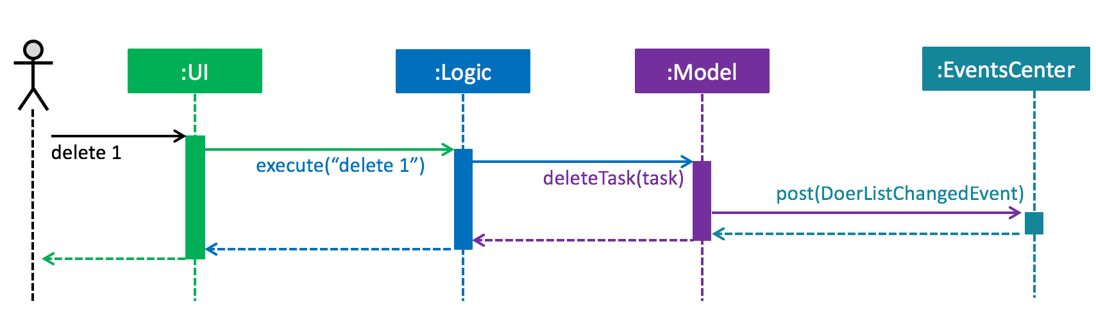
Note how the event is propagated through the EventsCenter to the Storage and UI without Model having to be coupled to either of them. This is an example of how this Event Driven approach helps us reduce direct coupling between components.
The sections below give more details of each component.

UI component
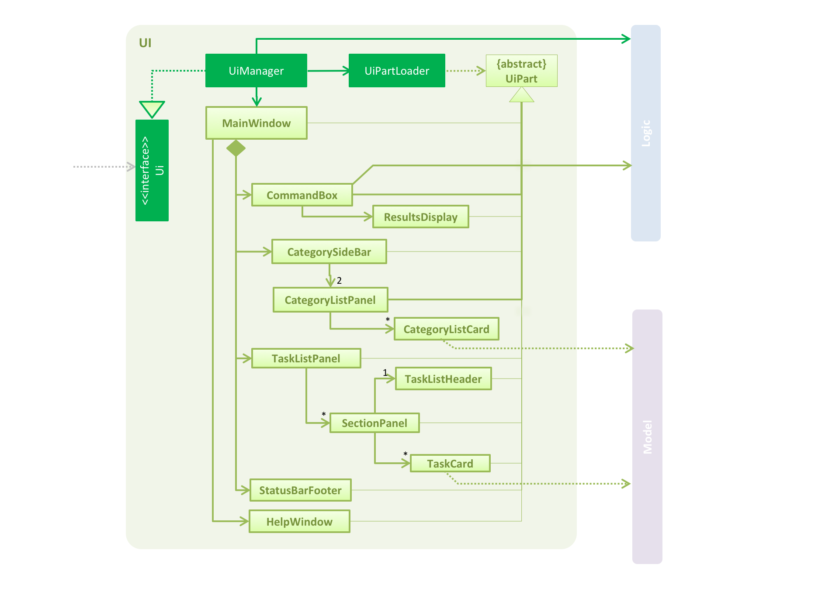
API : Ui.java
The UI consists of a MainWindow that is made up of parts e.g.CommandBox, ResultDisplay, TaskListPanel, StatusBarFooteretc. All these, including the MainWindow, inherit from the abstract UiPart class and they can be loaded using the UiPartLoader.
The UI component uses JavaFx UI framework. The layout of these UI parts are defined in matching .fxml files that are in the src/main/resources/view folder.
For example, the layout of the MainWindow is specified in MainWindow.fxml
The UI component,
- Executes user commands using the Logic component.
- Binds itself to some data in the Model so that the UI can auto-update when data in the Model change.
- Responds to events raised from various parts of the application and updates the UI accordingly. For example, the diagram below shows how the UI reacts to the JumpToIndexedTaskRequestEvent event.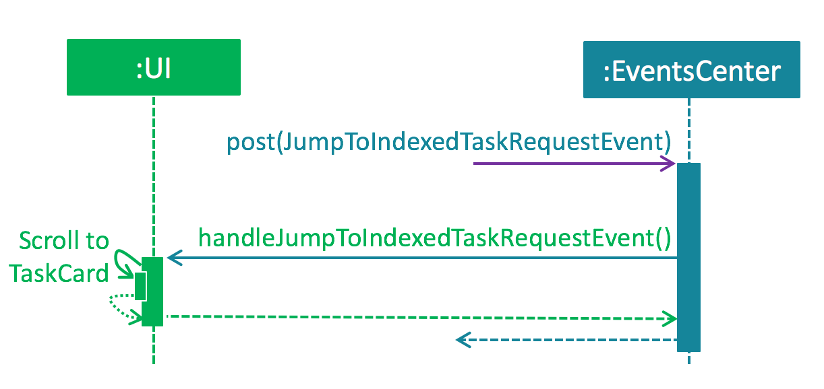

Logic component
API : Logic.java
- Logic uses the Parser class to parse the user command.
- This results in a Command object which is executed by the LogicManager.
- The command execution can affect the Model (e.g. adding a task) and/or raise events.
- The result of the command execution is encapsulated as a CommandResult object which is passed back to the Ui.
Given below is the Sequence Diagram for interactions within the Logic component for the execute ("delete 1") API call.
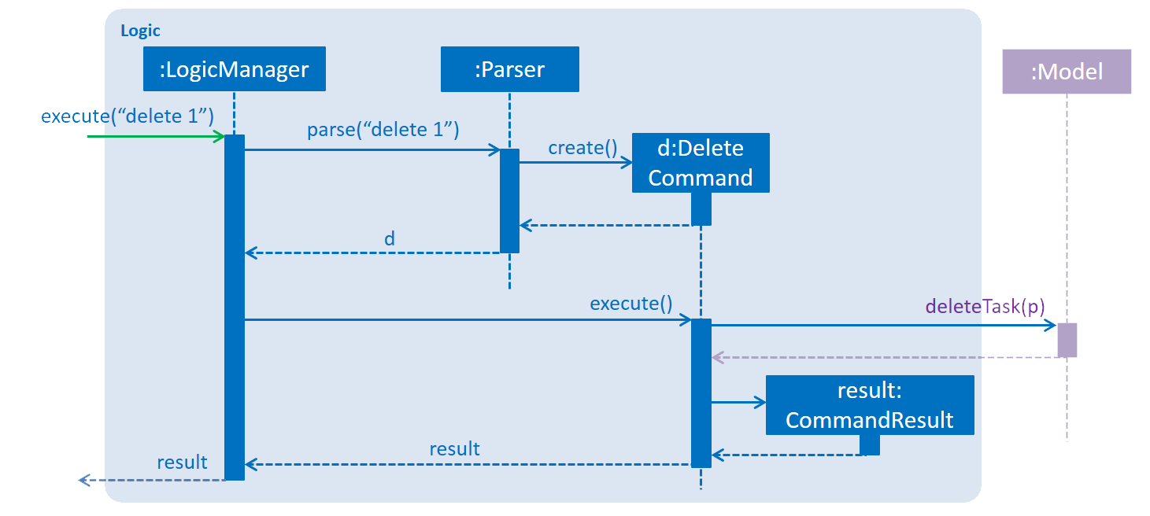

Model component
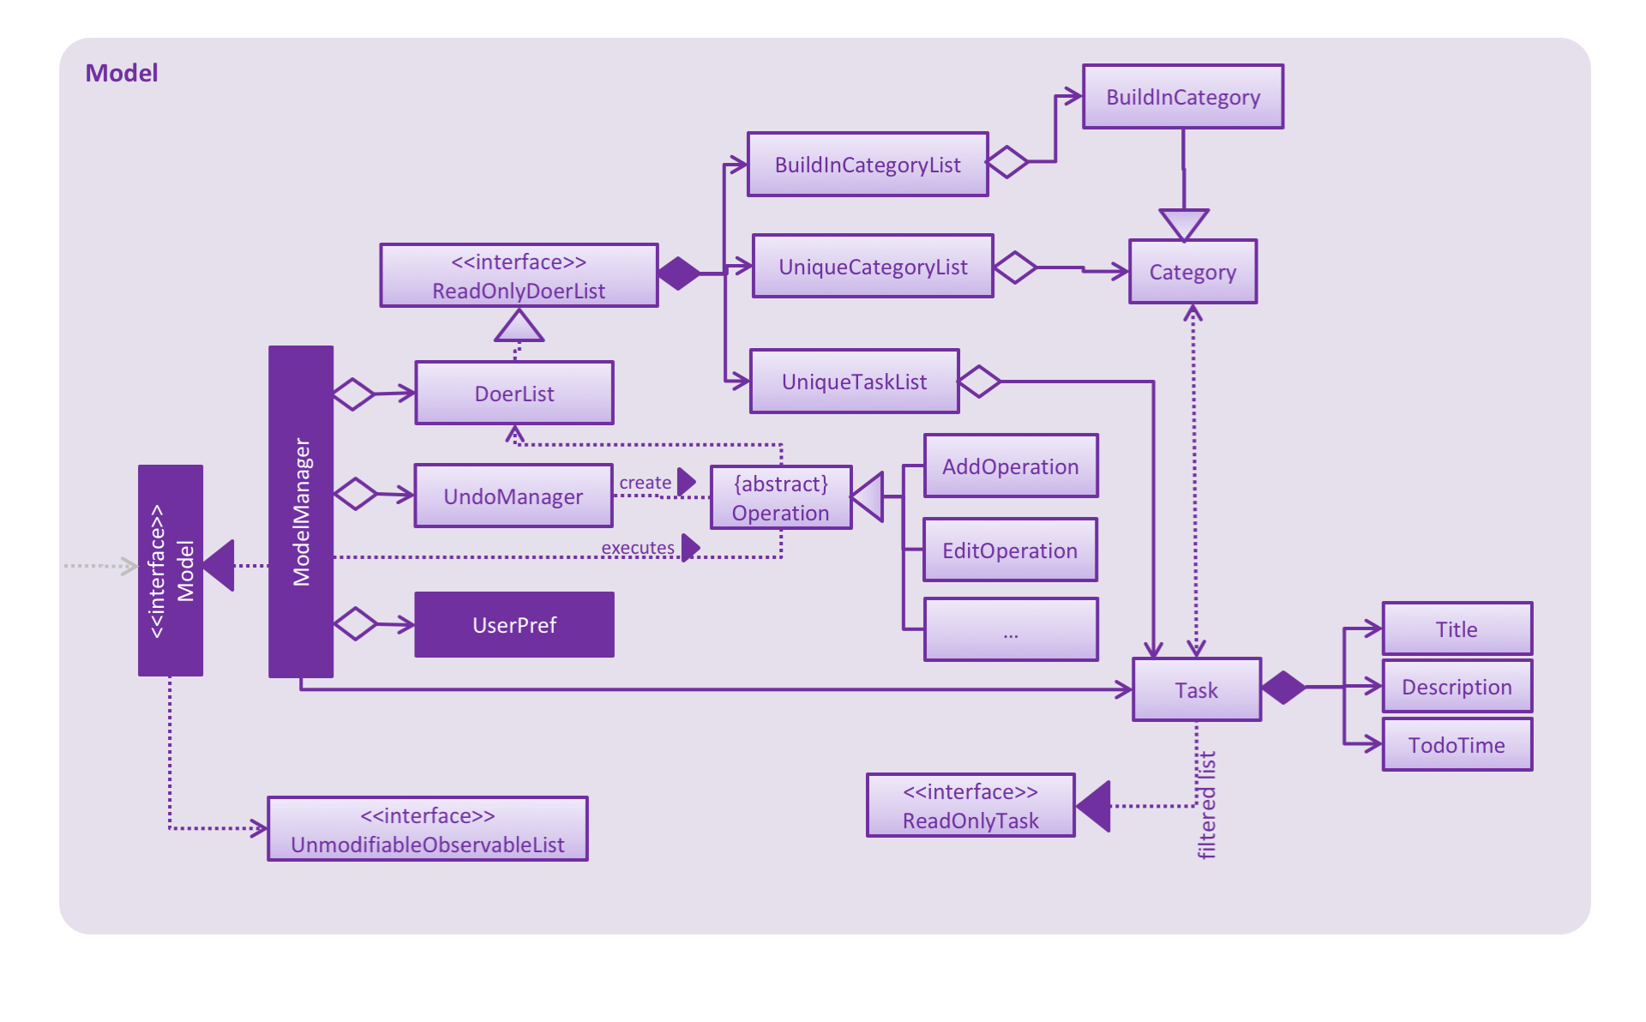 API : Model.java
The Model,
- stores a UserPref object that represents the user's preferences.
- stores the Do-er List data.
- stores a UndoManager that records the history operations to Do-er List data.
For example, when Model requests to add a task to Doer List, UndoManager will records the opposites operations (delete a task in this case) in its undo stack. Next time, when the undo method of the Model is called, Model will pull the first operation in the UndoManager and executes it. Meanwhile, UndoManager will push the operation to its redo stack. Therefore, next time when redo method is called, the Model could pull the first operation in UndoManager's redo stack and executes it.
- exposes UnmodifiableObservableList<ReadOnlyTask>, UnmodifiableObservableList<Category> that can be 'observed' (E.g. the UI can be bound to this list) so that the UI automatically updates when the data in the list changes.
- does not depend on any of the other three components.

Storage component
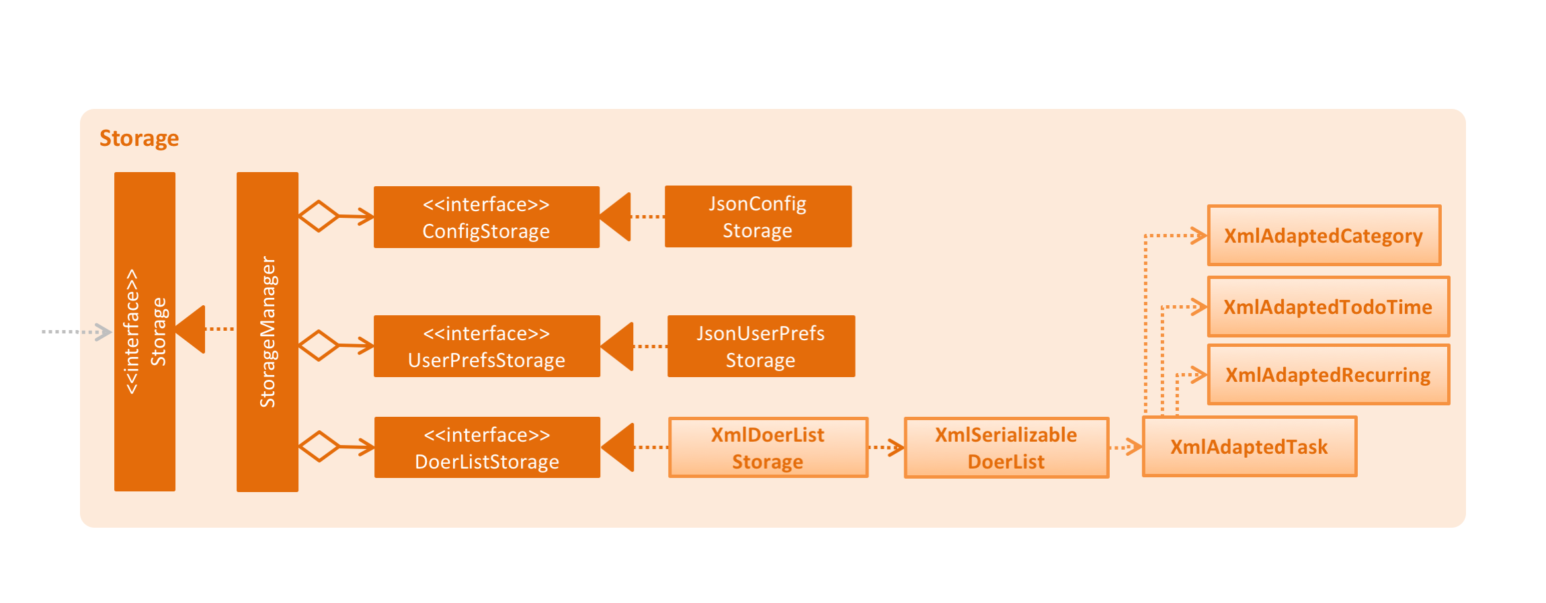
API : Storage.java
The Storage component,
- can save Config objects in json format and read it back
- can save UserPref objects in json format and read it back.
- can save the Do-er List data in xml format and read it back.

Common classes
Classes used by multiple components are in the seedu.doerList.commons package. Some of them are below:
- EventsCenter.java : The class is responsible for post events and handling events. When an event has been raised, the EventsCenter will check whether there is handler for the event and notify the correct handlers.
- LogsCenter.java: The class is responsible for recording the operation histories in execution. The records are useful for programmer in debugging.
- BaseEvent.java: The is the super class for every single event raised by the application.

Implementation

Logging
We are using java.util.logging package for logging. The LogsCenter class is used to manage the logging levels and logging destinations.
- The logging level can be controlled using the logLevel setting in the configuration file. (See Configuration)
- The Logger for a class can be obtained using LogsCenter.getLogger(Class) which will log messages according to the specified logging level.
- Currently log messages are outputted through Console and to a .log file.
Logging Levels
- SEVERE: Critical problem detected which may possibly cause the termination of the application.
- WARNING: Can continue, but proceed with caution.
- INFO: Information showing the noteworthy actions by the application.
- FINE: Details that is not usually noteworthy but may be useful in debugging. e.g. print the actual list instead of just its size.

Configuration
Certain properties of the application can be controlled (e.g App name, logging level) through the configuration file. (default: config.json):

Testing
Tests can be found in the ./src/test/java folder.
In Eclipse:
If you are not using a recent Eclipse version (i.e. Neon or later), enable assertions in JUnit tests as described here.
- To run all tests, right-click on the src/test/java folder and choose Run as > JUnit Test
- To run a subset of tests, you can right-click on a test package, test class, or a test and choose to run as a JUnit test.
Using Gradle:
- See UsingGradle.md for how to run tests using Gradle.
We have two types of tests:
- GUI Tests - These are System Tests that test the entire application by simulating user actions on the GUI. These are in the guitests package.
- Non-GUI Tests - These are tests that do not involve the GUI. They include:
  - Unit tests targeting the lowest level methods/classes.
e.g. seedu.doerList.commons.UrlUtilTest
  - Integration tests that are checking the integration of multiple code units (those code units are assumed to be working).
e.g. seedu.doerList.storage.StorageManagerTest
  - Hybrids of unit and integration tests. These tests are checking multiple code units as well as how the are connected together.
e.g. seedu.doerList.logic.LogicManagerTest

Headless GUI Testing: Thanks to the TestFX library that we are using, our GUI tests can be run in headless mode. In the headless mode, GUI tests do not show up on the screen. That means the developer can do other things on his computer while the tests are running.
See UsingGradle.md to learn how to run tests in headless mode.

Dev Ops

Build Automation
See UsingGradle.md to learn how to use Gradle for build automation.

Continuous Integration
We use Travis CI to perform Continuous Integration on our projects. See UsingTravis.md for more details.

Making a Release
Here are the steps to create a new release.
- Generate a JAR file using Gradle.
- Tag the repository with the version number. e.g. v0.1
- Create a new release using GitHub and upload the JAR file your created.

Managing Dependencies
A project often depends on third-party libraries. For example, Do-er List depends on the Jackson library for XML parsing. Managing these dependencies can be automated using Gradle. For example, Gradle can download the dependencies automatically, which is better than these alternatives.
a. Include those libraries in the repository (this bloats the repo size)
b. Require developers to download the necessary libraries manually (this creates extra work for developers)

Appendix A : User Stories
Priorities: High (must have) - * * *, Medium (nice to have) - * *, Low (unlikely to have) - *
Priority | As a ... | I want to ... | So that I can...
* * * | new user | see the usage instructions of all commands | how to use various commands in the application
* * * | user | create task with title and description | put summary as title and more details in the description
* * * | user | create task without start or end time | record tasks that need to be done without deadlines
* * * | user | create task with start and end time or deadlines | know what task I should be doing or due on a certain timing
* * * | user | edit task's title, description, start time, end time and categories | update it when I want to in the event I need to make some changes instead of creating a new task
* * * | user | view all tasks | have an overview of all the tasks
* * * | user | view a specific task | get more details of the specific task
* * * | user | find a task by title and description | quickly locate the task if I can only remember few words in the title or description
* * * | user | delete tasks | track only the required tasks
* * | user | add tasks to different categories | organise my tasks properly
* * | user | view the tasks under a certain category | examine different tasks under different categories
* * | user | view the tasks are going to happen or due today, tomorrow, next 7 days, etc. | know what is going to happen in the coming day(s)
* * | user | undo the most recent operations | revert the changes when I make a wrong command by mistake
* * | user | redo the most recent operations | redo the operation after undoing it
* * | user | specify a storage location for data storage | specify my data location to the cloud syncing service provider to prevent data loss
* * | user | mark or unmark the task as done | only need to keep track of the tasks which are needed to be done and archive the finished tasks
* | user | type command parameters in arbitrary order | find the specific order of parameter(s) in the event I forget
* | user | add external ical file to the todo-lists | keep track of tasks created by other applications.
* | user | create recurring tasks | be reminded to do the same task at the same time interval
* | user | view events in Google Calendar | have a better pictorial view of my schedule

Appendix B: Use Cases
(For all use cases below, the System is the Do-er List and the Actor is the user, unless specified otherwise)

Use case: Add task
MSS
- User requests to add a task in.
- System creates task with title, description, start date, end date, recurring interval.
- The task is moved into the categories according to the supplied parameters.
- System displays the details of the created task.
Use case ends.
Extensions
1a. add command followed by the wrong parameters.
1a1. System indicates the error and displays the correct format for user.
Use case ends.
2a. TITLE is empty string.
2a1. System indicates the error that TASK_NAME is empty.
Use case ends.
2b. User does not supply START or END parameters.
2b1. Task is created and categorized to INBOX.
2b2. System display the created task.
Use case resumes from step 2.
2c. User does not supply START parameter.
1c1. Task is created with START as today.
Use case resumes from step 2.
2d. System is able to parse START or END, which are not in standard format.
Use case resumes from step 2.
2e. System is unable to parse START or END, which are not in standard format.
2e1. System indicates the error to user.
Use case resumes from step 2.
2f. START time is after END time
2f1. System indicates the error to user
Use case ends
2g. There is not START time or END time while recurring interval is supplied
2g1. System indicates the error to user
Use case ends
3a. The category does not exist in the system
3a1. System creates a new category
Use case resumes from step 3
3b. The category does not exist in the system
3b1. System creates a new category
3b2. The category name is invalid
3b3. System indicates the error
Use case ends

Use case: Edit task
MSS
- User types in the command.
- System finds the task at that index.
- A new task is created based on new attributes and old attributes. (E.g. title, description, start time, end time, recurring interval, category).
- System replaces the old task with new task.
- System displays the details of the newly edited task.
Use case ends.
Extensions
1a. edit command followed by the wrong parameters.
1a1. System indicates the error and display the correct format for user.
Use case ends.
2a.edit command is followed by the non-existent INDEX.
2a1. System indicates the error that the INDEX is non-existent
Use case ends.
3a. System is able to parse START or END, which are not in standard format.
Use case resumes from step 2.
3b. System is unable to parse START or END, which are not in standard format.
3b1. System indicates the error to user.
Use case resumes from step 2.
3c. START time is after END time
3c1. System indicates the error to user
Use case ends
3d. There is not START time or END time while recurring interval is supplied
3d1. System indicates the error to user
Use case ends
3e. The category does not exist in the system
3e1. System creates a new category
Use case resumes from step 3
3f. The category does not exist in the system
3f1. System creates a new category
3f2. The category name is invalid
3f3. System indicates the error
Use case ends
4a. The replacement of task results in duplication in task list
4a1. System indicates the error
Use case ends

Use case: Delete task
MSS
- User types in the command.
- System finds the task at that index.
- System deletes the task.
Use case ends.
Extensions
1a. delete command is followed by the wrong parameters
1a1. System indicates error and display the correct format to user.
Use case ends.
1b. delete command is followed by a non-existent INDEX
1b1. System indicates the error in the INDEX is non-existent.
Use case ends.

Use case: List task by category
MSS
- User types the command with CATEGORY as parameter.
- System displays all the task under the CATEGORY.
Use case ends.
Extensions
1a. User does not supply CATEGORY.
1a1. System displays all the tasks.
Use case ends.
2a. The category does not exist in the system.
2a1. System indicates the error.
Use case ends.

Use case: Undo Command
MSS
- User types in the undo command.
- System tries to find the last operation that caused a change of data.
- System undoes the operation.
- System indicates the change to user.
Use case ends.
Extensions
2a. The last operation which involve the change of the data does not exist
2a1. System indicates the error.
Use case ends.

Use case: Clear Command
MSS
- User types in the command.
- System deletes all the tasks.
Use case ends.

Use case: Help Command
MSS
- User types in the command.
- System finds the details of a command with its parameters.
- System displays the details.
Use case ends.
Extensions
1a. help command is followed by the wrong parameters.
1a1. System indicates the error and displays the correct format for the user. Use case ends.
1b. help command is followed by no parameter.
1b1. System open the help windows
Use case ends.

Use case: View a task
MSS
- User types in the view command.
- System retrieves the task list based on the index parameter in the recent displayed list.
- System displays the detail of the task.
Use case ends.
Extensions
1a. view command is followed by the wrong parameters
1a1. System indicates the error
Use case ends
2b. The index is not valid.
2b1. System indicates the errors to user.
Use cases ends.

Use case: Find keywords
MSS
- User requests to find keywords.
- System shows the tasks with requested keywords.
Use case ends.
Extensions
1a. User doesn't supply keywords
1a1. System indicates the errors to use Use case ends.

Use case: Task Due Command
MSS
- User requests to find all tasks due by end date.
- System parse the DATE to standard form
- System List shows all of the tasks due by end date.
Use case ends.
Extensions
1a. taskdue command is followed by the wrong parameters
1a1. System indicates the error
Use case ends.
2a. System is able to parse the supplied DUE date to standard format
2a1. Use case resumes from step 2
2b. System is not able to parse the supplied DUE date to standard format
2b1. System indicates the error Use case ends.

Use case: Redo Command
MSS
- User types the command.
- System reverses the changes caused by the most recent undo.
Use case ends.
Extensions
1a. No recent undo is recorded.
1a1. System indicates the error and shows the error message. Use case ends.

Use case: Mark Command
MSS
- User request to mark task of INDEX done
- System find the task with INDEX number
- System marked the task as done.
Use case ends.
Extensions
1a. mark command is followed by the wrong parameters
1a1. System indicates the error
Use case ends
2a. System cannot find task with INDEX number.
2a1. System shows an error message.
Use case ends.

Use case: Unmark Command
MSS
- User request to mark task of INDEX undone.
- System find the task with INDEX number
- System marked the task as undone.
Use case ends.
Extensions
1a. unmark command is followed by the wrong parameters
1a1. System indicates the error
Use case ends
2a. The INDEX is invalid.
2a1. System shows an error message.
Use case ends.

Use case: Save Command
MSS
- User request to change the location of saving file.
- System changes the saving location
- System indicates the changing is successful.
Use case ends.
Extensions
1a. saveto command is followed by the wrong parameters
1a1. System indicates the error
Use case ends
2a. The saving path is invalid.
2a1. System shows an error message.
Use case ends.

Use case: Exit Command
MSS
- User request to exit the programme
- System terminated.

Appendix C: Non-Functional Requirements
- The program should work on any mainstream OS as long as it has Java 1.8.0_60 or higher installed.
- It should be able to hold up to 1000 tasks.
- Automated unit tests and open source code for this program should be readily available.
- Every operation executed should be logged to the log file.
- The program should favour DOS style commands over Unix-style commands.
- The product should not have dependencies on other packages.
- The software can be launched, without installing, by clicking on the executable file.

Appendix D: Glossary

Mainstream OS
Windows, Linux, Unix and OS-X

Deadline
A time interval with the start day as the day the task created day and the end day represents the date of the deadline.

Done
The built-in category in the system which store all the tasks that are marked as done.

Appendix E: Product Survey

Review of TickTick:

Strengths:
- Desktop software is provided, so we can launch it quickly without using a browser.
- Task are automatically categorised to Overdue Today Next 7 days and Complete, users can quickly find what they need to do in a certain day.
- User can create their own categories for tasks and allocate tasks to different categories.
- Elegant GUI is provided; the UI is not wordy and icons are quite intuitively.

Weaknesses:
- Network connection is required. If there is no network connection, the software even cannot be opened.
- The parser for input text can only deal with simple command.
  - E.g. Adding the start time of event. If the command cannot be recognized, it will be automatically added as task title.

Review of WunderList

Strengths:
- Ease of usage is the biggest strength. A user can easily add multiple items just by entering his desired items.
- Apple Watch integration is a nice bonus for Apple Watch owners.
- Slick user interface that allows background customizations.

Weaknesses:
- The free version has very limited features. Users only get 25 assigns per shared to-do list and 10 background choices.
- A constant network connection is required. If there is no network connection, the software cannot be opened.
- Wunderlist lacks IFTTT integration compared to other to-do list applications.

Review of Trello

Strengths:
- Online/Cloud based program that allows it to be transferrable to other computers.
- Ease to add in notes and description into Trello cards.
- Customizable looks.

Weaknesses:
- It cannot link up with other calendar software like Google calendar, which makes it hard to keep track of tasks done.
- The free version is much more limited than the paid version, making certain customisation features difficult to accomplish.

Review of Google Calendar

Strengths:
- Adds different kind of colouring to the schedule.
- Undo addition or deletion of events.
- Create multiple calendar for different purposes.
- GUI is quite intuitive. The formatting is clear and it does not require guidelines.
- Able to use calendar in offline mode.

Weaknesses:
- Unable to view all deleted events or reminders.
- It does not have command-line inputs to modify the calendar; most operations require a user to click, which can be time-consuming.
- Only accessible via browsers; no desktop application available.

